

Improving the Process of Course Evaluation:
The Online Alternative for Berkeley

Leadership Development Program
2004-2005

Table of Contents

Executive Summary 3
Project Team and Sponsors 5
Acknowledgements 6
Introduction 7
Methodology 8
Research Findings 10
Existing UC Berkeley Systems and Pilots 10
Best Practices 14
Student Survey 18
Faculty Interviews 24
Staff Interviews 26
Recommendations 29
Conclusions and Next Steps 35
Appendix A: Project Briefing from Sponsor 36
Appendix B: Project Proposal from Sponsors 43
Appendix C: LDP Team Project Scope Statement 45
Appendix D: Existing Systems Interviewees and Interview Questions 46
Appendix E: Best Practice Interviewees and Interview Questions 47
Appendix F: Student Survey Questions 49
Appendix G: Student Survey Charts 51
Appendix H: Faculty Interviewees and Interview Questions 61
Appendix I: Staff Interviewees and Interview Questions 63
Appendix J: Student Information Systems Mid Semester Evaluation Questions 65
Appendix K: Student Information Systems Prototype Application Screen Capture 68
Appendix L: UC Berkeley Homepage Student Survey Announcement 69
Appendix M: UC Berkeley Web Feature on Student Survey iPod Winner 70
Appendix N: Website Resource Summaries 72

Leadership Development Program 2004-2005

Improving the Process of Course Evaluation:
The Online Alternative for Berkeley

Executive Summary

As the University of California, Berkeley confronts the challenge of maintaining academic and research excellence in the face of diminishing financial resources, technology is often looked to for more efficient solutions to administrative challenges. One of the areas where the use of technology and the centralization of services could provide resource efficiencies at both the departmental and campus levels is the course evaluation process. Members of the campus community have articulated a number of concerns about the existing evaluation process at UC Berkeley, including:
- The significant costs to departments of the decentralized administration of evaluations.
- The inconsistency of the data used for merit, promotion and tenure decisions.
- The lack of aggregated evaluation data available to students.

As part of the campus Leadership Development Program (LDP), Vice Provost for Undergraduate Education Christina Maslach and Assistant Vice Provost for Undergraduate Education Barbara G. Davis sponsored a project to examine various aspects of moving the campus from a paper evaluation process to an online evaluation process. The LDP project team was asked to:
- Identify the best practices in online evaluation systems.
- Identify what Berkeley faculty, staff and students need and want in an online evaluation system.
- Describe the key characteristics of the desired online evaluation system.
- Propose effective strategies to make a smooth transition from paper and pencil to electronic collection of course evaluation data.

In performing research within the UC Berkeley campus community, the team employed a number of survey methodologies to identify expectations and concerns about moving to an online evaluation system, as well as to identify features that would be required of the system. Approximately 40 faculty and staff were selected for in person interviews. Student opinions were solicited via an online survey which elicited over 1100 site visits, and close to 800 completed responses. In addition, five peer universities that have successfully moved from a paper and pencil to an online evaluation process were selected and appropriate staff identified for phone and email interviews. The institutions included were:
- Columbia University
- Drexel University
- Northwestern University
- University of California, Irvine
- Yale College

After nearly three months of data gathering and analysis, the project team developed the following recommendations:

Application Development
- Continue to develop the Online Course Evaluation application internally through the Office of Student Information Systems.
- Include end users (faculty, staff and students) in the application development and testing process to ensure usability and promote user buy in.

Integration
- Integrate the Online Course Evaluation application with existing campus systems.

Funding
- Provide funding at the campus level to continue the development and implementation of a new Online Course Evaluation system.

Required Features
- Require students to either complete or opt out of completing evaluations prior to viewing grades online.
- Open the evaluation window from two weeks prior to the end of final exams until grades are available online.
- Design the Online Course Evaluation application with the need for flexibility and user customization in mind.
- Allow for mid semester evaluations.
- Include robust reporting functionality.
- Provide security of data and anonymity for respondents within the application.

Policies and Procedures
- Formalize and publish policies governing the use of online evaluation data before the application is implemented.

Student Response Rate
- Provide student access to some of the evaluation results.
- Educate students about the importance of evaluations for enhancing teaching quality and promote participation as an act of good community citizenship.
- Encourage students to fill out evaluations by providing incentives (prize drawings, discounts, etc.).

Implementation Strategies
- Educate and provide training to faculty and staff about the new system.
- Identify an Online Course Evaluation project management team.

Further detail about these recommendations and summarized research data can be found in the Project Team’s full report.

Project Team and Sponsors

Project Team

Eric Anglim, Property Manager, Business Services
Ellen Chang, Business Manager, Electronics Research Laboratory
Ricky Freed, Network Development Supervisor, IST-CNS
Karen Berk Marcus, Assistant Director, International Relations, University Relations
Liz Marsh, Director of Information Systems, University Extension
Sian Shumway, Computing Staff Supervisor, IST-W&MF
Trang Tran, IT Manager, Capital Projects

Project Sponsors

Christina Maslach, Vice Provost, Division of Undergraduate Education
Barbara G. Davis, Assistant Vice Provost, Division of Undergraduate Education
Michael Hardie, Teaching Grants Administrator, Educational Technology Services

Acknowledgements

The LDP Online Evaluation Project Team would like to express our gratitude to our sponsors:

Barbara G. Davis, Assistant Vice Provost of Undergraduate Education
Michael Hardie, Teaching Grants Administrator
Christina Maslach, Vice Provost of Undergraduate Education

We would also like to thank the following individuals whose support made our work possible:

Chansonette Buck, Senior Analyst – OHR, and LDP Process Consultant
Inette Dishler, 2004/2005 Leadership Development Program Manager
Jeff Kahn, Manager, UC Berkeley Homepage and NewsCenter websites
Karen Kenney, Dean of Students
Steve Garber, Operations Manager – Haas School of Business, and LDP Participant
Seamus Wilmot, Administrative Analyst – Recreational Sports, and LDP Participant
Our supervisors, colleagues and staff.

Thanks as well to UC Berkeley for providing us with this exceptional opportunity to expand our professional horizons.

Introduction

At the University of California, Berkeley every course is evaluated by students each time it is offered. A portion of class time is set aside for students to fill out paper evaluation forms at the end of each semester. The evaluations include a variety of quantitative and qualitative questions designed to assess the course and the instructor’s effectiveness. Responses are collected and tabulated by the department to give the faculty feedback on teaching performance, and for use in personnel actions, including merit, promotion and tenure cases.

While many other administrative tasks, such as course registration and the posting of grades, have been converted to online processes, student course evaluation is still primarily a paper process. UC Berkeley is not alone. In a 2002 study of 500 educational institutions, only ten percent used a campus wide online course evaluation system to collect student ratings. The study concluded, however, that the number of institutions using online evaluation systems was growing.

For some time, the campus has been aware of deficiencies in the paper based system. The paper process is labor intensive, requiring significant staff time and resources to manually tabulate quantitative ratings and to transcribe or photocopy qualitative comments. The workload can be substantial, in particular for large undergraduate courses. Faculty sometimes wait months to see the evaluation results, which are not always presented in a useful report format. In most cases students do not have access to the evaluation results to help them make decisions about which courses to take. Lack of access to this data may become an even greater student concern as of Fall 2005, when the course add/drop deadline will be earlier in the semester.

Several departments have made independent efforts to publish the results of their paper based evaluations online. A few others have implemented online course evaluation systems with the ability to collect responses via the web. Student Information Systems, in collaboration with the Office of Educational Development, has developed a prototype online evaluation application that has been piloted on campus on a small scale during the 2004-2005 academic year. However, UC Berkeley has yet to implement a campus wide online evaluation system.

Responding to the campus need for a more efficient system, Vice Provost Christina Maslach, Assistant Vice Provost Barbara G. Davis, and Teaching Grants Administrator Michael Hardie, commissioned a Leadership Development Program project to research an online alternative to the paper process. The Online Course Evaluation Project Team was directed to assess the best practices in online evaluation systems at comparable educational institutions and to determine what would work best at UC Berkeley. In addition to researching peer institutions, the Project Team solicited input from the key stakeholders—faculty, staff, and student—to establish the desired criteria for designing, implementing and effectively using an online evaluation system. This report presents the methodology, findings, and recommendations of the Project Team.
Methodology

The Project Team was assembled in January 2005 to investigate and develop recommendations for an online course evaluation system at the University of California, Berkeley. The Project Sponsors, Vice Provost Christina Maslach, Assistant Vice Provost Barbara G. Davis, and Grants Administrator Michael Hardie, presented the team with a project proposal entitled, "Improving the Process of Course Evaluation: The Online Alternative for Berkeley" (Appendices A and B).

The Project Team conducted a stakeholder analysis to determine who would be interviewed and then defined the project scope (Appendix C). The Team was split into five subgroups, each charged with researching a specific area of the project, as follows:
- Group 1 researched existing online evaluation projects underway at UC Berkeley
- Group 2 researched best practices at peer institutions
- Group 3 investigated student needs
- Group 4 investigated faculty needs
- Group 5 investigated staff needs

The groups developed survey questions and a list of interviewees (Appendices D through H), which were vetted with the Project Sponsors in mid March. The questions focused on the challenges of current systems, student response rate issues, access to evaluation data, and the benefits of and concerns about moving to an online system. Interviews and data collection took place in March and April 2005.

Group 1 (Existing Systems) interviewed representatives from Student Information Systems, who designed a prototype for mid semester evaluations, piloted during the Fall 2004 and the Spring 2005 semesters. The team also identified and interviewed other departments on campus, who have either created their own online evaluation system, or have used an existing online tool for this purpose. The team investigated how these systems work, the challenges to implementation, the costs of transition, etc.

Group 2 (Best Practices) identified peer educational institutions currently using online evaluation systems for their entire campus, or select departments. A "peer" institution was defined as an academically distinguished, top research institution with a comparable student population. The team conducted interviews by telephone and email with those involved with the development, planning and implementation of successful systems and programs at the following institutions:
- Columbia University
- Drexel University
- Northwestern University
- University of California, Irvine
- Yale College

Group 3 (Students) determined that the most effective method for reaching a large number of students would be to conduct an online survey. The team developed an eight question survey and used Zoomerang.com, a web-based survey tool, to collect responses. In addition, a paper version of the survey was available in the Recreational Sports Facility (RSF) lobby. The survey went live on April 5 and was available for six days. The site received 1199 visits, and 787 students completed the questionnaire. To encourage participation, the team worked with the Dean of Students to distribute an announcement of the survey via email to 700 student organizations. In addition, the team worked with Public Affairs to post an announcement and link to the survey on the UC Berkeley homepage. As an incentive, enrolled students who completed the survey were entered into a grand prize drawing for an iPod.

Group 4 (Faculty) identified a list of deans, department chairs, and chairs of key Academic Senate committees to be interviewed. Faculty were selected from a diverse range of departments and academic disciplines to represent the needs and concerns of those who are evaluated and those who review the results for personnel actions such as, merit, promotion and tenure reviews.The group conducted sixteen interviews, and received fourteen written responses to the questionnaire.

Group 5 (Staff) conducted interviews with administrative staff who have responsibility for the management of the evaluation process for their department, as well as those staff who would need to be involved in the development and implementation of a campus wide evaluation system (e.g., Campus Registrar, Director of Academic Personnel, Executive Director of the Office of Planning and Analysis). In addition, the group consulted members of the campus community who have experience with the development and implementation of large scale campus technology initiatives.

Response data was compiled for review and analysis.

Research Findings

Existing UC Berkeley Systems and Pilots

Current Practices and Challenges

Student Information Systems Online Course Evaluation Application
Student Information Systems (SIS) has been developing an Online Course Evaluation application designed to address the specific needs of UC Berkeley. As part of the development and testing process, SIS has implemented two mid-semester evaluation pilots in collaboration with the Office of Educational Development. In Fall 2004, 22 courses in 6 departments participated. In Spring 2005, 22 courses in 11 departments participated. The pilots used a standard set of 8 questions (Appendix I). Customization of questions was not possible in the pilot. Results were distributed as delimited text or PDF files directly from SIS to participating faculty. The purpose of the pilots thus far has been to garner feedback on its design, test authentication and usability, and to collect data on response rates. An end-of-semester pilot is planned for Spring 2005, when Industrial Engineering and Operations Research (IEOR) and College Writing will conduct their final evaluations online.

The prototype for a campus wide system is currently in development. Thus far, SIS has spent approximately 680 hours of development time, or $48,960 (calculated at the standard SIS programming rate of $72/hour). Completing the administrative side of the application to allow authorized departmental users to create evaluations would take an estimated 600 hours, or $43,200, of additional development time. These numbers do not reflect costs associated with building reporting functionality into the application. SIS anticipates that ongoing support costs will run about $20,000 per year.

The prototype is built with a top down hierarchy that includes the following levels of customization (Appendix J):
- Campus Level Options
- College/School Level Options
- Department Level Options
- Faculty Level Options

The SIS application addresses all user concerns for security and anonymity. Students are authenticated using their CalNet ID, which ensures secure access by allowing only authorized users into the system. When students log in, they are offered a list of their classes by course control number (CCN) downloaded from the Student Information Database containing course enrollments data. This ensures that students can only submit evaluations for classes in which they are enrolled. Students may only submit one evaluation for the class. Once the evaluation is complete, attempts to submit another evaluation are not allowed. Finally, anonymity is achieved by storing evaluation data and user data in two separate locations that are not tied to each other.

The application has been developed in Java to work seamlessly on both Macintosh and Windows platforms. The website is all text, and testing for Americans with Disabilities Act compliance will be coordinated with the Center for Disabled Students on campus.
Currently, further development of the application is on hold due to shifted priorities as a result of decreased staffing from budget cuts. SIS staff continue to believe this is an important project with significant demand across campus.

SIS hosts a student forum each summer on technical issues and initiatives. SIS Director JR Schulden offered to host a session in Summer 2005 on Online Course Evaluations to gather additional feedback from students on how to successfully implement a centrally administered evaluation application.

Graduate School of Education Online Course Evaluation Application
As a result of a reorganization that cut the operating budget in half, the Graduate School of Education (GSE) developed their own online course evaluation system under the direction of Lisa Kala. A pilot was launched in Fall 2003, and continuous development occurred between Fall 2003 through Spring 2004. The implementation of the system has resulted in reduced administrative workload and costs. Prior to the implementation of the online system, merit, promotion and tenure cases were delayed by the burden of the paper process. The Graduate School of Education is unique in that it uses its evaluations not only for course evaluation, but also to evaluate programs within their credentials program.

The application was developed by one full time staff programmer analyst. One of the main concerns for students was insufficient time on the last day of instruction to give adequate evaluations. To address this concern, the evaluation site is open during the last three weeks of class. Students login with their CalNet ID to access evaluation forms. Student ID numbers and evaluations are stored in two separate locations to ensure confidentiality. The student then sees the list of classes offered by the department. They are unable to limit by course control number due to the late add/drop deadline. At this time, due to technical security issues, the GSE system is unable to access the required course control number data directly from the central Student Systems database. They are currently working to resolve this issue. The system prevents more than one evaluation per person by creating a unique ID for each evaluation. Students are allowed to resubmit their evaluation for each course by returning to it at a later time. The latest complete version of the evaluation at the close of the evaluation period will be kept. The online evaluation form used is identical to the department’s paper evaluation form. No customization is allowed.

There has been a considerable amount of development on the administrative side of the application to allow faculty to easily obtain results and data from the system. The extensive Frequently Asked Questions (FAQ) section of the website to assist faculty in using the system was modeled after the FAQ in use on Yale College’s online course evaluation system. Reports can be accessed by Faculty directly, and is secured via CalNet authentication. Lisa Kala reported significant departmental cost savings, the elimination of transcription errors, as well as considerable time savings in calculations of data. She reported there is still much resistance to the system among the faculty.

Professor Marti Hearst Online Course Evaluation Pilot
Professor Marti Hearst from the School of Information Management and Systems (SIMS) wanted to experiment with online course evaluations using the free online service, Survey Monkey. In the first semester, her pilot was fairly successful in that high response rates were achieved. Professor Hearst suggested the service to other faculty in the school who used it for their classes. Results were discouraging. The issues were:
- Response rate: high response rates were achieved in elective classes, however, unacceptably low response rates in required core courses led to the discontinuation of using Survey Monkey.
- Anonymity was impossible to achieve through this free service.
- Difficult to enforce only one response per student.

Professor Hearst stated that using this online service was a failure because it was unable to accommodate the varied needs of faculty and students.

Professor Hearst specializes in human-computer interaction and user interface design. While being interviewed she stated her interest in testing the application and helping to design the user interface.

Desired Features

Several key features for an Online Course Evaluation system were identified through these interviews. Requested features include:

Application
- Flexibility to customize questions.
- Reporting: current data reports as well as historical reporting, statistical analysis, comparisons by course or faculty.
- Develop a database of questions to improve the evaluation form and usage.
- Use the system for mid-semester evaluations and other non-personnel related purposes such as exit interviews.
- Provide ability to follow up with students 1 to 2 years after a course to determine importance/relevance of class.

Administration
- Provide adequate training for those who will administer the system.
- Provide central funding to relieve burden on departments.
- Develop campus policy by which limited results are published to guarantee higher response rates and create a participatory culture.
- Ensure the system is looked at from the department administrator’s perspective to guarantee ease of use.

Student Response Rate

All those interviewed about existing online systems at UC Berkeley identified response rate as the primary concern about moving to online course evaluations.
- The average response rate for the Student Information Systems mid semester pilots was 20%.
- The average response rate in the School of Education is 40% online versus 80% on paper.
- At SIMS, the response rate varied widely based on the size of the class and the type of class (e.g., elective or required core course).

All suggested the use of some sort of incentive to motivate student participation. Most interviewed suggested positive incentives like prizes or discounts to prevent negative response bias.

Best Practices

The findings presented in this section are the result of interviews conducted with the following peer institutions that have successfully moved from a paper to an online evaluation process.
- Columbia University
- Drexel University
- Northwestern University
- University of California, Irvine
- Yale College

Current Practices and Challenges

Columbia University
The transition to online course evaluations at Columbia University was initiated and led by students in the Campus Computer and Electronics Services and Engineering and Applied Sciences departments. The students formulated the requirements, planned the implementation criteria, developed the systems and proposed the program.
- The online evaluations included both a set of system wide core and course specific questions.
- Students are given access to core question responses to assist in course selection.
- Student anonymity is guaranteed by separating the authentication method from the database that collects, stores and produces the data.
- During the transition period, incentives including iPod drawings and extra credit points, were used to encourage student participation.
- After implementation was complete, incentives were discontinued. Current practice is to withhold grades for a course until the evaluation is complete.
- Students must now submit an evaluation or opt out in order to receive final grades.
- The Department of Academic Computing was solely responsible for defining the functionality and developing the system, and now oversees the management of the system as well as the updates/upgrades.
- Quantitative evaluation results are published.
- Average student response rate on paper: 50-60%.
- Average student response rate online: 90%.

Drexel University
In 1998, the College of Engineering, with support from the Gateway Engineering Education Coalition, led the development of an online course evaluation program. This team also included in the development process select students and staff whose experience was seen as valuable. The resource costs of the paper based evaluation process prompted the University to seek a web-based alternative for course evaluations.
- Evaluation questions for undergraduate courses are standardized on a departmental level. Graduate level course evaluation questions are course specific.
- Quantitative data is made available to students. Qualitative data is reviewed by the department prior to publication.
- Student identifiers are removed from course evaluations to ensure anonymity.
- Multiple types of incentives are used to boost response rates, including cash incentives, Palm Pilot raffles and pizza parties.
- Average student response rate on paper: 30-40%.
- Average student response rate online: 89% (with incentives).

Northwestern University
In order to alleviate the resource burden associated with the paper evaluation process, the Course and Teacher Evaluation Council (CTEC) was established to set up an electronic evaluation site for each undergraduate level class with enrollment of five or more students.
- Questions are standardized at the campus level, with the capacity for course specific questions included in the system.
- Evaluation results of all classes are posted on the CTEC section of the Registrar’s web page unless instructors specifically request in writing that their results be withheld.
- In order to guarantee anonymity, students are their campus authentication credentials to access the evaluation site.
- Incentives include offering two extra points on grades, access to grades as soon as evaluations are completed, and the ability to view peer responses for future course selection.
- The Office of the Registrar and the CTEC share the administration of the program.
- Average student response rate on paper: 35%.
- Average student response rate online: 90-100% (with incentives).

University of California, Irvine
UC Irvine’s transition to online course evaluations was based on a proposal by UC Irvine’s Senate Committee, Committee on Teaching and the Council on Student Experience. In 2000, as part of its Course Management System, an online mid-semester evaluation and optional final course evaluation tool were implemented. Since 2000, the online tool has been adopted school wide by several academic units.
- The system uses a standard evaluation form which allows four customized questions per course.
- Results of evaluations are not published.
- Responses are kept confidential by not linking student identification information to the evaluation file.
- There are no mandated incentives. Some faculty chose to give extra credit.
- The system is centrally administered: hosted on the Course Management System, and maintained by Network & Academic Computing Services.
- Average student response rate on paper: 40%.
- Average student response rate online: 90% (with incentives).

Yale College
The Yale College Committee on Teaching and Learning (CTL) began to investigate online evaluation options in 1997. A campus wide system was implemented in 2002.
- Six core questions were incorporated system wide. Of those, two are course specific. Instructors are permitted to include additional course specific questions with approval from the CTL.
- Responses to three of the six core questions are accessible by students.
- Anonymity is guaranteed by removing any reference to identifying information prior to inclusion into the database systems.
- During the transition period, incentives including campus discounts, cash incentives, iPod drawings and pizza parties, were used to encourage student participation.
- After implementation was complete, incentives were discontinued. Current practice is to withhold grades for a course until the evaluation is complete.
- Average student response rate on paper: 40%.
- Average student response rate online: 100% (including opt out responses).

Student Response Rate

Both Yale College and Columbia University were more concerned with response rate than any other issue. Institutions with this priority withheld grades until completion of course evaluation. This strategy yielded high response rates.

All five institutions achieve between 89% and 100% response rates. Northwestern and Drexel offer ongoing incentives to achieve these high response rates. Drexel stated that they provide several types of incentives because their research has shown that no one incentive will motivate all potential respondents. Neither Yale, Columbia, nor UC Irvine offer campus wide incentives, although UC Irvine faculty offer extra credit on a case by case basis.

All universities offer an opt out option. Yale achieves a 100% response rate by considering an opt out choice as a completed evaluation response. It is interesting to note that no other institution researched calculates response rate in this way.

Desired Features

Without exception, each institution noted the importance of the following features:
- Guaranteed anonymity of respondents
- Customization of questions
- Data security and availability
- Inclusion of incentives to achieve higher response rates
- Ease of maintenance and modification
- Reporting capability

Key Findings

Implementation Strategies
Our peer institutions reported that early and exhaustive planning was critical to the success of their move from paper to online course evaluations. Most of them miscalculated how much time implementation would take, and they all discovered that they had not planned adequately. All five institutions discovered that it was more efficient to design a custom online evaluation format than to try to duplicate their existing paper format in the online environment.

All five peer institutions used surveys, campus wide discussion groups and interviews of faculty, staff and students in the development and implementation of their online course evaluation system. Each institution also established criteria for standardized campus or department wide core questions for their online evaluations.

Publishing results varied between schools
Apprehension about publishing course evaluation results was universal. There was concern over student anonymity as well as having student comments made widely available. Some institutions were able to reach agreement on these issues by making sure that the decision making process was inclusive of those affected by it. Columbia, Northwestern and Yale publish quantitative responses, but qualitative responses are available only to faculty, deans, chairs and individuals responsible for the accumulation and presentation of data pertaining to personnel review and retention processes. Drexel publishes quantitative results, and qualitative results after departmental review. UC Irvine does not universally publish results.

All five universities developed their application internally
Most of the universities researched and tested third party or vendor products, but did not select them. Instead, they incorporated best features from those solutions and developed internal applications. All vendor options available were susceptible to mishandling of the data as well as security issues.

Concerns about the transition to an online format
All five of the peer institutions had concerns about the move to an online format. Student anonymity and confidentiality of evaluation data were critical to the acceptance of the programs and systems. Much of the total resource expenditure was directed at assuring respondents’ anonymity. In addition, mapping out system requirements and achieving buy in from all affected populations was seen as essential prior to embarking on development. Another core concern was the ability to administer and manage system functionality centrally. Centralized management allowed campus stakeholder committees to establish standards and improve the quality of the evaluation process.
Student Survey

Student opinions were solicited via a survey conducted over a period of five days in both online and paper format. The online survey generated 1199 site visits and 766 completed responses. Twenty-one students filled out paper surveys, for a total survey response of 787. In addition to responding to quantitative questions, the students also provided a total of 1400 individual qualitative comments.

Current Practices and Challenges

Eighty percent, or 614 of 767 respondents, said that they had never participated in an online evaluation at UC Berkeley or any other educational institution. Seventy-nine percent, or 611 of 770 respondents indicated that they would be willing to fill out online course evaluations outside of class time. Respondents who had experience with online evaluations were asked to provide comments on their likes and dislikes.
- 57 respondents noted that online course evaluations were easy and time saving.
- 30 respondents mentioned experiencing difficulties with complicated user interfaces.
- 22 respondents identified the lack of access to survey results as a negative experience.

Have you ever participated in an online course evaluation at Berkeley or any other higher educational institution?

0
100
200
300
400
500
600
700
Yes
No
# of Responses

614

153

Total 767 Responses

Sixty-eight percent, or 513 of 759 students, indicated that they do not use course evaluations as a guide in the selection of classes or instructors. Of the 513 who do not use evaluation results, 503 cited the following reasons:
- 67% have no access to evaluation results
- 13% indicated that their classes are required, so they have no choice in class selection
- 11% perceive little or no value in the evaluation results
- 9% use word of mouth instead

0
100
200
300
400
500
600
Yes
No
# of Responses

246

513

Total 759 Responses
Do you currently use course evaluation results as a guide in the selection of your classes or instructor/faculty?

Forty seven percent, or 353 of 746 respondents, stated they do not believe their evaluations have had an impact. The lack of access to evaluation results and the perceived lack of impact of student feedback were identified as the major deterrents to participation in the current evaluation process.

Total 746 Responses
0
100
200
300
400
500
Yes
No
# of Responses
Do you think the evaluations you have completed have had an impact?

393
353

Desired Features

When asked to rate the importance of convenience, time commitment, access to summarized results, and anonymity and confidentiality, on a scale of “Not at all” to “Crucial”, 43%, or 328 of 755 respondents, selected anonymity and confidentiality as the issue of greatest concern to them about completing evaluations online.

Selected as Crucial
Total 755 Reponses
0
50
100
150
200
250
300
350
Convenience
Time Commitment
Access to Summarized Results
Anonymity and Confidentiality
# of Responses
Please mark the importance to you of the following for completing a course evaluation - convenience, time commitment, access to summarized results, anonymity & confidentiality.

78
113
236

328
Not important -> Somewhat important -> Important -> Very Important -> Crucial
Considerations

Student Response Rate

When asked to rate the importance of proposed incentives – earlier access to grades, UC Berkeley student discounts, access to evaluation summaries – the majority of respondents selected access to evaluation summaries as crucial.

Total 517 Responses
0
50
100
150
200
250
Earlier Access to Grades
UCB Student Discount
Access to Evaluation Summary
Given Benefits of Completing Course Evaluations Online
# of Responses
Please indicate the attractiveness of each of the following benefits of completing course evaluations online: Earlier access to grades, UCB Student Discounts, Access to evaluation summaries.

129

158

230
Students were also asked what other incentives not mentioned would motivate participation. Of 471 comments, responses were distributed as follows:
- 36% prizes (e.g., tickets, food, and textbooks)
- 20% the ability to make an impact is a sufficient enough motivator
- 20% no other incentive is necessary
- 10% extra course credit
- 3% make participation mandatory

Total 471 Responses
0
20
40
60
80
100
120
140
160
180
Extra Credit
Prizes, Tickets, Food
Knowing That I Made a Difference
Making It Mandatory
Easy to Use, Convenient & Confidential
No Other Incentive Necessary
# of Responses

What other incentives not yet mentioned would motivate student participation?

45

170

93
15

56
92
Suggested Incentives From Students

Faculty Interviews

Current Practices and Challenges

The current paper course evaluation process is administered in class during the last few weeks of the semester, when it is believed that the greatest number of students will be in attendance. The evaluation takes, on average, 10-30 minutes of class time, with student response rate ranging between forty and ninety percent. Evaluation forms are provided to the class instructor, who then gives them to a student (or students) to administer in the instructor’s absence. Results are then tabulated by department staff, who in many cases transcribe any written comments to preserve the anonymity of the student evaluator. In cases where written comments are not transcribed, the anonymity of the student is not guaranteed, as an instructor could recognize a student’s handwriting. Evaluation administration, including distribution, tabulation, transcription and duplication, creates a significant drain upon departmental staff time and resources.

Course evaluation formats vary, but there is a fair amount of consistency in that each department uses at least one quantitative question on a 1-7 point scale, and qualitative questions that seek open-ended comments from students. In the current process, qualitative comments require transcription in order to guarantee student anonymity.

Although processing time varies widely across departments, faculty often may not have access to evaluation results until well into the next semester, if not later. Commonly faculty can only access qualitative responses by reviewing them in the department office. Few departments make evaluation results available to students.

There were several reported instances of evaluation tampering, where the documents were not strictly guarded and tracked. In addition, cases of tabulation and transcription error were also reported, and in at least one case the errors were not caught until the instructor’s case was up for merit review.

A significant number of faculty employ some unofficial form of mid semester evaluation, which is sometimes simply a conversation with the class. Faculty tabulate the results themselves, and use the results to adjust their course/teaching.

The use of evaluation results varies widely among faculty. Some faculty are disinterested in the results. Others use the results to assess their teaching effectiveness, the learning environment of the class, and the tools used in teaching, and actively seek opportunities to make adjustments where appropriate.

Faculty focus on their numeric ranking (generally on a 1-7 scale) but many find their rankings discouraging. While qualitative responses can be the source of great anxiety due to the potential for student mischief, faculty frequently stated that the comments contained the richest, most meaningful information.

Online System Concerns

Faculty interviewed expressed concern that student participation will decrease with an online process. They fear students may not see the importance of their participation if the process is removed from the classroom. A significant number of faculty interviewed agreed that some form of coercion will be necessary to ensure maximum student participation.

An overwhelming majority of faculty do not want evaluation comments made available to anyone other than those presently dictated by campus administrative requirements. One faculty member stated that in a class of 100, there are always several students who are not satisfied, and a few negative comments can skew an otherwise strong numeric evaluation average. Faculty are generally most concerned about publishing qualitative comments online, fearing that with an audience students may be tempted to give inappropriate or “creative” responses.

Faculty instructors are further concerned with the amount of training needed to use an online application.

Desired Features

Faculty want the ability to customize evaluations at the departmental and course levels in order to obtain more relevant data. Several faculty also mentioned the desire to gather demographic information to assist with results analysis, such as how many hours the student studied for the class and whether the class is required for the student’s major.

Faculty unanimously requested that a menu of reports be included in an online evaluation system, as well as the ability to receive raw data that could be further analyzed.

Faculty also noted that security of data and student anonymity must be provided by the new system.

Student Response Rate

Faculty suggest that student participation may be assured through one or more of the following:
- Withholding grades until the student’s evaluation is completed.
- Providing students access to certain evaluation data if they participate.
- Making participation a requirement in order to take their final examination.
- Providing students with some portion of class credit (points).
- Making evaluation participation a course requirement.

In addition, many felt that students should be required to fill out an evaluation as a condition of dropping a class.

Staff Interviews

Of the eleven staff interviewed for this project, six work in academic departments, and the remaining five work in service or administrative departments. With one exception, staff are very much in favor of moving to an online course evaluation system. The one exception is Dennis Hengstler, the Executive Director of the Office of Planning and Analysis. He believes that UC Berkeley should move to a centralized evaluation model for administrative purposes, but that the evaluations should still be done in class in paper form (using Scantron forms). This is primarily due to his concern about response rate and potential response bias.

Otherwise, staff were excited about the possibility of the centralization of a process that is so inconsistently managed across campus and that requires so many departmental resources. The list of potential benefits to an online system includes:
- Will allow for better reporting and use of data.
- The standardization of metrics could help historical comparative reporting.
- Data accuracy would be improved.
- The elimination of paper would free up physical storage space.
- Valuable class time will be saved.
- Students will have more time to reflect and give thoughtful responses without the constraint of classroom time limits.
- Will provide a common reporting document with which everyone is familiar.
- Will allow customization of evaluations by course format (lecture, seminar, lab, etc.), resulting in more meaningful data.

Current Practices and Challenges

Of the six academic units represented, Boalt and Haas manage their quantitative evaluation data within a database that also makes those results available online. Boalt makes the data public to their own students, and Haas makes the results available to the general public. Both are graduate professional schools.

All departments devote a significant amount of resources to managing evaluations. In addition to duplication and materials costs:
- One department estimates they use ¼ of an AA II level FTE (~$11,000 + benefits).
- One department estimates they use ½ of an AA II level FTE.

One half of the departments interviewed use Scantron forms, and two thirds transcribe all qualitative comments. Some departments distribute only quantitative results to faculty, while others distribute both quantitative and qualitative results (the latter either transcribed or photocopied).

Online System Concerns

There were many concerns expressed by the staff interviewed about moving to an online system. Aside from the issue of response rate, where concern was almost unanimous, other common concerns were about getting buy in from faculty, and making sure that the online evaluation process was incorporated into centralized systems already in use by and familiar to the campus community. Other concerns include:

- Whether there was a campus commitment of sufficient resources to provide for ongoing maintenance and improvement of the system.
- For departments that do currently make evaluation results available, whether their students could continue to access results as they do now.
- That the application be sufficiently load tested prior to rollout (in particular, problems with the eGrades system rollout was mentioned several times).

Desired Features

Interviewed staff unanimously mentioned the need for stringent security measures to guarantee anonymity and protect the sensitive data being collected. Academic department interviewees consistently stressed the need for the system to provide robust reporting, access to raw data and department and faculty level question customization. Other features that one or more interviewees requested include:
- A staff/faculty education and training program as part of the system implementation
- The ability to use multiple scales (e.g., 3,5 and 7 point) within a single evaluation.
- Accommodation of courses with multiple instructors and multiple models (team teaching vs. chronological teaching).
- The inclusion of role based summary reporting (e.g., reports for the Committee on Budget, Chairs, Deans, Academic Personnel staff, faculty).
- Expansion of the single campus wide standardized question into two questions, one on course effectiveness and one on instructor effectiveness.
- Accommodation of Graduate Student Instructor evaluations.
- Integration with other relevant campus databases (e.g., Class Schedule and Instructional Record system (CSIR) and the Human Resource Management System (HRMS) Faculty Activities module) and systems (TeleBEARS, bSpace, etc.).

In addition, Campus Registrar Susie Castillo-Robson urged the development of an official campus wide policy that would clearly state the rules and regulations governing the use of the evaluation data being collected by the new system. Particularly because this data will be centrally located within a single system, the Registrar anticipates an increase in the number of requests for access to the data, by both academic researchers as well as commercial interests such as RateMyProfessor.com. The policy idea was echoed by others in the interview population.

Student Response Rate

The potential decline in student response rate with an online evaluation system was a concern shared almost universally across the staff interview population.

Over 85% of respondents felt that this issue should be addressed by restricting student access to online grades until their evaluations had been completed. All felt that participation could be promoted to some degree by a combination of the following measures:
- Making evaluation data available to students.
- Provision of incentives like raffles, coupons, or discounts.
- Promotion of the idea of good community citizenship.
- Education about how evaluation data is used and its importance to faculty merit, promotion and tenure.
- Creation of a standardized student use only section on evaluations, the results of which made public for students (but not to be included as part of the faculty personnel action cases).

Other

Other comments by those interviewed included the desire that the system be adequately tested by users before it is rolled out to the campus at large. User expectations should be appropriately set by clearly identifying what the system will and will not do up front. Several interviewees mentioned the attractiveness of having a menu of approved evaluation questions from which to choose when building course evaluations. Finally, one interviewee expressed interest in potentially using the system to meet other evaluative needs, such as student exit interviews.

Recommendations

Application Development

Continue to develop the Online Course Evaluation application internally.
All peer institutions consulted for this project indicated that they had developed an internal application. Although third party vendor solutions were investigated, it was determined that an internal application was the best approach given the data management and security risks involved in using outside vendors.

UC Berkeley's department of Student Information Systems has already begun development of an online course evaluation prototype, which addresses issues of security and anonymity. Therefore, we recommend that the campus support the continued development of the evaluation application under the aegis Student Information Systems.

Include end users (faculty, staff and students) in the application development and testing process to ensure usability and promote user buy in.
Interviews with faculty, staff, and students revealed the universal desire for the new application to be easy and intuitive to use. Best practice research indicates that the most effective way to achieve this goal is to seek the input of end users throughout the development process.
- The development team should employ use cases to determine requirements for usability and reporting needs (e.g., focus groups, campus wide advisory group)
- The development team should perform rigorous testing with actual end users prior to implementation.
- The application should be well load tested before rollout.
  - A number of interviewees and survey respondents mentioned the negative experience of the eGrades system rollout, when the system hadn’t been adequately load tested, resulting in login denial or delay, slow performance and general user frustration.

Integration

Integrate the Online Course Evaluation application with existing campus systems.
Interviews with members of the Educational Technology Committee (ETC) noted that it will be important to tie online teaching evaluations into students’ existing workflow. Incorporating the online evaluation application into systems like TeleBEARS (and ultimately bSpace) that students already know and use will encourage participation and facilitate the adoption of the new online evaluation application. The SIS prototype currently under development appears to be designed to meet this goal.

The campus is also looking at ways to streamline the academic personnel review process for faculty. Course evaluations are an important part of this process, therefore the online evaluation application should be developed keeping systems integration in mind. More specifically, the online application should integrate with existing administrative databases such as Class Schedule and Instructional Record (CSIR), as well as with the planned Faculty Activities module of the Human Resources Management System (HRMS) database. Integration of these systems will lead to the availability of richer, more consistent data across campus, and will reduce staff time involved in putting together academic review cases.

Funding

Provide funding at the campus level to continue the development and implementation of an online course evaluation system.
Student Information Systems has spent approximately 680 hours of development time on the Online Evaluation application. At the standard SIS programming rate of $72/hour, the total cost to date is $48,960. SIS estimates that completing the administrative component of the application, which will allow authorized departmental users to create evaluations, will take another 600 hours ($43,200) of development time. Reporting capability will require further development resources. The campus also needs to determine the ongoing costs related to application maintenance and improvements after the initial rollout of the application. The campus should identify a source of funding for this project before moving ahead with development.

Required Features

Provide security and confidentiality of data and the anonymity of respondents within the application.
Faculty, staff and students all mentioned anonymity, security and confidentiality as critical concerns. Without exception, peer institutions interviewed recognized these factors as essential and included mechanisms to address the concerns in their systems. In addition, the applications also must ensure that only students enrolled in a class can complete an evaluation and allow only one response per student.

Require students to either complete or opt out of completing evaluations prior to viewing grades online.
Many faculty and staff interviewed believe that students should not be allowed to view their grades online before they complete their course evaluations. However, a significant number of interviewees also cited a concern about potential negative response bias if students were forced to fill out evaluations. Best practices at peer institutions allow student to opt out of the evaluation process. This is generally accomplished by presenting students with a screen requesting that they complete their course evaluations prior to being allowed to view their grades. At this point students can opt out of completing the evaluations, and can move on to view their grades.

Open the evaluation window prior to the end of final exams until grades are available online.
Many faculty interviewed requested that students complete evaluations before the final exam. To address this concern, the evaluation window should open prior to the end of class. If, however, the campus wishes to use TeleBEARS to remind student to complete evaluations when they go to check for grades, the window for completing evaluations will need to extend at least until grades become available online.

Design the online evaluation application with the need for flexibility and user customization in mind.
Interviewees consistently mentioned the need for the application to be flexible and customizable. Requested features include:
- Flexibility to customize questions at the departmental and course levels.
- Ability to use both quantitative and qualitative questions.
- Allow for multiple scales (e.g., 3, 5 or 7-point) within a given evaluation.
- Ability to handle courses with multiple instructors (including. Graduate Student Instructors) and multiple models (team teaching vs. chronological teaching)
- The application interface should be easy and intuitive to use.
- Students should receive automatic email notification when an evaluation period opens, then receive periodic reminders until they complete their evaluations or the evaluation period ends.
- Application should allow sufficient time for students to fill out evaluations without timing out.

Allow for mid-semester evaluations.
Sixty two percent of faculty interviewed said that they use an informal mid semester evaluation, noting the value of this data. They also expressed interest in using an online tool for this purpose if it were available and easy to use. Eighty percent of faculty participants in the Spring 2005 mid semester online pilot stated how useful it was to receive immediate feedback during the term, when suggested changes could be addressed.

Include robust reporting functionality.
The need for standard reporting was mentioned consistently by faculty and staff as a necessary feature for an online evaluation application. Specifically:
- The application needs to provide a standardized summary report that includes standard statistical metrics.
  - A good example of this kind of report can be found on the Haas School of Business web site, at http://web.haas.berkeley.edu/facultyevals/Fall04_Evals/default.asp
- Reports should accommodate the needs of a majority of departments.
  - To determine specific reporting requirements, user input needs to be solicited.
- There should be a menu of summary reports for various roles that will need access to the evaluation data.
  - For example, summary reports for the Academic Senate’s Committee on Budget, departmental Chairs and Deans, Academic Personnel at both the campus and departmental levels, and individual faculty should all be available.
- The application should allow the user to download raw data in standard ASCII-delimited format(s) for purposes of departmental level analysis.

Policies and Procedures

Formalize and publish policies governing the use of online evaluation data before the application is implemented.
Faculty, staff and students all expressed concerns about how data collected by the online evaluation application will be used. In particular, the Campus Registrar, Susie Castillo-Robson, expressed reservations about centrally storing this data without official policies to govern its use. In addition, data stewardship roles and responsibilities should be determined, assigned and published.

Student Response Rate

Student response rate was identified as a critical area of concern in moving from paper to online evaluations. Although the change in the conditions under which evaluations will be completed (outside the classroom, not constrained by time, etc.) could lead to better, more thoughtfully considered evaluations, many worry that it may also reduce the response rate. Best practices dictate that a multi-tiered approach to promoting a good response rate is most successful. Specific recommendations include:

Provide student access to some level of evaluation results.
Forty four percent, or 230 of 517 of student respondents, indicated that having access to evaluation data would be necessary to motivate them to complete course evaluations. In addition, four out of five institutions surveyed for best practices made quantitative results available to students.

While the majority of UC Berkeley faculty had significant concerns about publishing evaluation results, the concern was greatest about the publication of qualitative results. Because both student response and best practice institution procedures clearly demonstrate that some form of evaluation data publication will be crucial to achieving a good response rate, a compromise could be reached by using one or more of the following strategies:
- Publish the results of UC Berkeley’s single standardized question.
- Create a set of 2-3 questions that are intended only for student use and are not included in the faculty personnel data;
- Allow faculty to opt out of having their results published for any given semester.
- Providing students access to evaluation data only if they participate.

Educate students about the importance of evaluations for enhancing teaching quality and promote participation as an act of good community citizenship.
Participation in the evaluation process was mentioned across staff and faculty interview populations as an important student responsibility. Students should be reminded that their evaluations are an important part of the teaching process and that their participation will benefit not only themselves but also future students. This should be done in as many forums across campus as possible (by faculty in class, by student advisors, etc.). Faculty may also wish to assign completion of the evaluation as a class assignment to boost response rate.

Encourage students to fill out evaluations by providing incentives (prize drawings, discounts, etc.).
Each of the institutions interviewed as part of this research used some sort of incentives during the transition period, and in some cases beyond, in order to maximize student response rates. Incentives included extra credit points, Palm Pilot giveaways, pizza parties, and cash prizes. The student survey conducted on campus also supported the finding that incentives would be useful in motivating student participation at UC Berkeley. Based on our findings, we recommend that several types of incentives be used because no one incentive will motivate all potential respondents.

Implementation Strategies

Educate and provide training to faculty and staff about the new system.
Faculty and staff both mentioned negative experience with previous UC Berkeley system rollouts. At issue was the lack of clear communication about what the system would provide for them. Communicating with faculty and staff early in the implementation process, and setting clear expectations about what the system will and will not do, will promote buy in and will ease the transition to the new system. Develop a formal implementation plan which includes detail about testing, rollout timelines, scope of deliverables, etc.

Training should be available for faculty and staff who will use the system, and should continue on a permanent schedule. Demonstrations of the application should be conducted for faculty and staff to solicit feedback. Key faculty and staff should also be identified who can help educate colleagues about and promote the new system.

Identify an Online Course Evaluation project management team and functional owner.
A project of this magnitude will have a significant impact on the campus community. The importance of project planning and management cannot be underestimated, particularly given the number of people and systems that will be affected. Each of the peer institutions consulted had appointed a team of people to guide the project from development to implementation.

Future Considerations

Following are recommendations that could be considered for implementation in later phases of the project, but were not deemed essential to include in the initial roll out.
- Consider developing additional questions for required use across campus.
Most peer institutions interviewed had three to five standardized questions required on all campus evaluations.
- Collaborate with the Office of Educational Development to develop an online database of evaluation questions.
- Include student demographic information in evaluation reporting to provide richer data for analysis.
- Provide historical comparison reporting capability.
- Provide ad hoc reporting capability.
- Consider using the application to expand the scope of evaluations to support improvements in other areas of student, faculty and administrative work life (e.g., for exit interviews or program evaluations).
- Consider requiring students to fill out an evaluation as a condition of dropping a class.

Conclusions and Next Steps

The research conducted by the Online Course Evaluation Project Team has shown that a successful transition from paper to online evaluations at UC Berkeley should include the following characteristics:
- Inclusion of user feedback in the development and testing of the application.
- Flexibility to customize evaluations to suit departmental and instructor needs.
- Well defined pilot and implementation plans.
- Forward thinking marketing, education and training campaigns preceding and accompanying implementation.
- Sufficient positive incentives to ensure student participation.

The Project Team has outlined a number of recommendations that will be important to consider over the course of the transition period. The Team advises that the following recommendations be addressed as soon as possible:
- Develop policies governing the use and stewardship of the data.
- Identify an Online Course Evaluation project management team and functional owner.
- Identify users (faculty, staff and students) to participate in developing reporting system criteria.
- Create an implementation plan to determine the schedule by which the testing, piloting, marketing and rollout of the online system will happen.

Appendix A: Project Briefing from Sponsor

Improving the Process of Course Evaluation:
The Online Alternative for Berkeley

A Briefing for LDP Team Members

Contents

• Berkeley’s Current Course Evaluation System
• Current Online Projects Underway at Berkeley
• The Task
• What the Task Is Not
• Some Relevant Resources
• Project Sponsors
• Contacts Cited in this Briefing

Berkeley’s Current Course Evaluation System

By campus policy, every course every semester is evaluated by the students enrolled in that course. These evaluation questionnaires (also called student rating forms) are administered at the end of each semester: hard copy forms are passed out sometime during the last week of class and students are given class time to complete the questionnaires, asking about their experiences in the course.

Administration of this paper and pencil course evaluation system at Berkeley is primarily the responsibility of each course instructor’s home department. The department is responsible for developing the questions and preparing the forms, for distributing and collecting them, and for ensuring that they are administered in a manner that will guarantee student anonymity. Course evaluations are usually a mix of quantitative and qualitative (narrative) questions, and only one single question, recently approved by the Academic Senate and the campus administration, is required of all course evaluations on the Berkeley campus.

Some departments publish the summarized results of the evaluations so that interested students can see them; most departments do not. Of those that do publish them, at least two make them available online. The Haas School of Business publishes student evaluations of its faculty at a website open to anyone (http://web.haas.berkeley.edu/FacultyEvals/) while the School of Law publishes online summaries for its students only (http://www.law.berkeley.edu/currents/registrar/teachingevals.html).

Many courses at Berkeley also use GSIs (Graduate Student Instructors, often referred to as TAs or Teaching Assistants at other universities) to assist in instruction; usually, the GSIs conduct discussion sections or oversee lab sessions, and in some instances are the principal instructor for a course. They, too, are evaluated by their students each semester.

Additionally, students in some courses (e.g., freshman seminars) must complete additional evaluations because the courses are part of a special program. Some faculty have stated that the amount of class time given over to the administration of multiple course evaluations has become excessive. They look to the development of an online course evaluation system as a relief.

Current Online Projects Underway at Berkeley

To meet demand for an online alternative, several projects are underway:

1. The office of Student Information and Systems (SIS) is working on the programming end of things, developing the computer based tools that will on the one hand, connect to the back end student database, while on the other allow each department to create its own set of evaluation questions. Important contact people in this effort are J. R. Schulden, Director of SIS, and Yu-Tin Kuo.

2. The Graduate School of Education (GSE) is continuing work on a project begun last fall to bring its course evaluations online. It is working collaboratively with SIS in this effort. The contact person for this project is Lisa Kala.

3. The Office of Educational Development (OED), under the auspices of the Academic Senate’s Committee on Teaching, is working on four separate projects related to online course evaluations. The contact person for these projects is Steve Tollefson

- Project One: a pilot formative project — an online questionnaire that faculty can administer during the semester to get feedback on their teaching. First attempted in Fall 2004, another pilot will be undertaken again in Spring 2005.

- Project Two: a pilot summative project — an end-of-semester online course evaluation questionnaire scheduled for spring 2005. One department, College Writing Programs, has already agreed to participate in the project this spring..

- Project Three: consulting with those departments willing to participate in the fall 2006 pilot to redesign, as appropriate, their end-of-semester course evaluation forms.

- Project Four: gradually developing an online database of evaluation questions that have been reviewed and vetted by COT and other interested Senate committees from which departments, faculty, and GSIs can select appropriate items to create their own questionnaires.

4. Though not currently engaged in the development of online course evaluations, Professor Marti Hearst of the School of Information Management and Systems (SIMS) previously directed a small online course evaluation project involving her courses and those of a few other SIMS faculty members.

The Task

The LDP team is being asked to:

- identify the best practices in online evaluation systems (from the research literature and the experiences of other universities)
- identify what Berkeley faculty, staff and students need and want in an online evaluation system
- describe the key characteristics of the desired online evaluation system
- propose effective strategies to make a smooth transition from paper and pencil to electronic collection of course evaluation data

The task is not just how to move the current paper and pencil course evaluation system online but rather to look at all the variables and features of online course evaluation systems, then make a recommendation about the kind of system and its features that would be best for Berkeley.

To that end, team members will need to interview such key Berkeley campus stakeholders as

- representative deans and department chairs;
- representative staff who are entrusted with making the current systems work;
- the current and next chair of the Academic Senate;
- representatives of key Academic Senate committees (e.g., the Committee on Educational Policy, the Budget Committee, the Graduate Council, and the Committee on Teaching);
- representatives for both undergraduate (the ASUC, particularly the office of the Vice President for Academic Affairs) and graduate students (the Graduate Assembly);
- GSI representatives such as the Dean of the Graduate Division and the Director of the GSI Teaching and Resource Center;

The LDP team may also need to interview representatives from those units that currently oversee student systems and data (e.g., Student Information Systems, the Registrar's office, the Educational Technology Committee) and whose participation is crucial to the development and implementation of an online system.

Additionally, team members will need to research and identify comparable institutions that are currently using online systems for a whole campus or just selected departments, then contact appropriate representatives at those institutions to learn why they installed an online system, how they installed it, how it currently works, and both what aspects of the respective systems have worked and what haven't. Yale and Northwestern are two universities that have installed large scale systems. At other universities, including UC Irvine and UCSF, specific departments have moved their course evaluations online. Some of these universities and departments are using home grown systems while others have contracted with external vendors.

Critical issues in online evaluation systems include:

- security, confidentiality and anonymity - security (a) so that only the students enrolled in a course can fill out the evaluation forms, and then only once, and (b) so that an online system cannot be “hacked” and compromised; confidentiality and anonymity so that both students and faculty can be properly protected:
- student response rate and how to achieve a high rate of students completing online questionnaires;
- procedures for insuring a quick turnaround of results so that instructors get student feedback in a timely fashion;
- accessibility and ease of use of online evaluation forms, particularly for students with disabilities.

Additionally, because one of the forces driving the consideration of a move to an online environment is cost, it will be helpful for the team to consider both current (paper and pencil environment) and projected (online environment) costs in its examination. It's not expected that the team will be able to do an analysis of all the relevant cost issues, but it would be helpful if the team could identify the relevant costs associated with transitioning from one environment to another.

What the Task Is Not

The course evaluation system consists of both products and processes. The products are the evaluation forms themselves, the questions - both quantitative and qualitative - that departments use to evaluate the teaching of their faculty and the data that results from the administration of the evaluations. The processes are the methods by which the evaluations are administered, tabulated, summarized, and distributed. The LDP project will focus only upon the latter, the processes, though it is free to note any impact upon the content of evaluations that the transition to an online environment might make.

Some Relevant Resources

UC Berkeley Policy for the Evaluation of Teaching
http://apo.chance.berkeley.edu/evaluation.html

Campus Administrative Memo Articulating the Single Question Policy
http://www.berkeley.edu:5027/cgi-bin/deans_memos/deans_memos.pl?search_results=20&display_memo=1402&search_subject=evaluation&search_body=&search_from=&search_to=&search_date_to=2/1/04&search_date_from=04/01/02

UC Teaching, Learning, & technology Center (TLtC) article on course evaluations
http://www.uctltc.org/news/2004/04/feature.html

Using the web for student evaluation of teaching
http://home.ust.hk/~eteval/cosset/qtlconf.pdf

Online Student Evaluation of Instruction: An Investigation of Non-Response Bias
http://airweb.org/forum02/550.pdf

Online Student Evaluation of Teaching in Higher Education
http://onset.byu.edu/

Online Student Evaluation of Teaching in Higher Education: An annotated Bibliography
http://onset.byu.edu/OnSETbiblio.htm

Web-Based Student Evaluation of Instruction: Promises and Pitfalls
http://www.drexel.edu/provost/ir/conf/webeval.pdf

Plugging in to course evaluation
http://ts.mivu.org/default.asp?show=article&id=795

Yale University Online Course Evaluation FAQ
http://classes.yale.edu/help/itg/oce/faq.htm

Northwestern University Course & Teacher Evaluation Council
http://www.registrar.northwestern.edu/ctec/

Project Sponsors

Christina Maslach, Vice Provost, Undergraduate Education
642-9594; maslach@berkeley.edu

Barbara Gross Davis, Assistant Vice Provost, Undergraduate Education
642-6392; bgd@berkeley.edu

Michael Hardie (co-sponsor and principal facilitator for the LDP team)
Educational Technology Services, 9 Dwinelle Hall
643-9433,; hardie@berkeley.edu

Contacts Cited in this Briefing

Louise (JR) Schulden, Director, Student Information Systems (SIS)
642-1618; schulden@socrates.berkeley.edu

Yu-tin Kuo, Programmer, Student Information Systems
642-6679; yutin@berkeley.edu

Lisa Kala, Director, Educational Technology Service Center
Graduate School of Education
642-8420; lisak@berkeley.edu

Steve Tollefson, Faculty Development Coordinator
Office of Educational Development (OED)
642-6392; tollef@berkeley.edu

Prof Marti Hearst, School of Information Management & Systems (SIMS)
642-1464; hearst@sims.berkeley.edu

Prof Robert Knapp (Classics)
Chair, Berkeley Division of the Academic Senate
642-4218; rcknapp@socrates.berkeley.eldu

Prof Alice Agogino (Mechanical Engineering)
Vice Chair, Berkeley Division of the Academic Senate (will be chair for 2005-06)
642-3458; aagogino@me.berkeley.edu

Prof J. W. Morris (Materials Science & Engineering)
Chair, Committee on Teaching, Academic Senate
642-3815; jwmorris@berkeley.edu

Prof Margaretta Lovell (Art History)
Chair, Committee on Educational Policy, Academic Senate
643-7290; mmlovell@berkeley.edu

Prof Janet Broughton (Philosophy)
Chair, Budget and Interdepartmental Relations Committee, Academic Senate
642-2722; broughton@berkeley.edu

Prof Andrew Szeri (Mechanical Engineering)
Chair, Graduate Council, Academic Senate
643-0298; andrew.szeri@berkeley.edu

Misha Leybovich, President
Associated Students of the University of California (ASUC)
642-1433; president@asuc.org

Rocky Gade, Academic Affairs Vice President
Associated Students of the University of California (ASUC)
642-0256; aavp@asuc.org

Rishi Sharma (Law)
President, Graduate Assembly
642-2175; ga_president@berkeley.edu

Rob Schechtman (German)
Academic Affairs Vice President, Graduate Assembly
(510) 325-7901; schecht@berkeley.edu

Prof Mary Ann Mason, Dean, Graduate Division
642-3170; graddean@berkeley.edu

Prof Joseph Duggan, Associate Dean, Graduate Division
642-2712; jjddean@berkeley.edu
Linda von Hoene, Director
GSI Teaching and Resource Center
642-4456; vonhoene@socrates.berkeley.edu

Susan Castillo-Robson, University Registrar
642-2261; scr@berkeley.edu

Prof Philip Stark (Statistics), Chair
Educational Technology Committee (ETC)
642-2781; start@stat.berkeley.edu

Prof Richard Lyons, Acting Dean
Haas School of Business
642-1059; lyons@haas.berkeley.edu

Appendix B: Project Proposal from Sponsors

“Improving the Process of Course Evaluation: The Online Alternative for Berkeley”

Sponsors: Vice Provost Christina Maslach, Assistant Vice Provost Barbara G. Davis, Division of Undergraduate Education

Project Facilitation: Michael Hardie, Educational Technology Services

Background
Teaching is a core function of the university, and faculty work hard to develop and deliver the best possible curriculum for our students. But how well do they achieve that lofty goal? The evaluation of teaching is an important aspect of educational accountability and is a critical component of faculty progress through the academic ranks.

Although there are many sources of evidence with regard to teaching, the primary one that is used by all departments on this campus is student evaluations. At the end of the semester, students are given paper forms to fill out anonymously in class. These forms are unique to each department, and vary in both content and format (with the exception of a single standard rating item, which is now required on all forms by the Budget Committee). Departmental staff must then tabulate the quantitative ratings, and retype (or photocopy) the qualitative comments, in order to: 1) provide feedback to the faculty member, and 2) compile the evidentiary case for any personnel action. The amount of staff time that is spent on this task is enormous and costly, and many staff have asked that an alternative, electronic solution be found for this major workload problem. This request is being reiterated with increasing urgency by many department chairs and deans.

Students are also calling for a better form of course evaluation. Here the major concern is that, although students put in time and effort to answer all the evaluation forms, they do not have access to the aggregated results. Most departments do not post the results in a public way, and restrict the information (when it is finally tabulated) to the relevant faculty member and department chair. Consequently, when students are considering which courses to take, and with what instructor, they are deprived of a critical piece of information, namely the evaluations made by prior students. Over the years, the ASUC has tried to develop alternative evaluation systems that are shared publicly, but these have been difficult and costly to sustain. Now students are even more concerned about getting better information about courses, given that there will be an earlier drop deadline as of Fall 2005.

This constellation of student, staff, and faculty concerns has led to current efforts to develop an online system for course evaluation. Both the Senate Committee on Teaching and the Educational Technology Committee are working on different aspects of this issue, and have initiated some pilot projects in conjunction with Student Information Systems. However, to move forward effectively, the campus needs to assess the best practices in online evaluation systems at other educational institutions and to determine what would work best at UC Berkeley.

Scope

The LDP project is designed to assess the best practices in online evaluation systems at other educational institutions and to determine what would work best at UC Berkeley in terms of the design, process and implementation of such a system. The project will consist of the following:

A. Research and Analysis

The LDP team will:

- Interview key campus stakeholders (faculty, staff, and students) to determine the desired criteria for designing, implementing and effectively using an online evaluation system. These criteria will include the method for collecting evaluations from students, the compilation and presentation of the aggregated results, issues of response rate and anonymity, and others.
- Assess the online systems that are in use at 3-5 comparable educational institutions to determine best practices with regard to the desired criteria.
- Assess how well online systems were implemented at other institutions, and identify best practices for designing an implementation strategy at UC Berkeley.

B. Recommendations (based on research and analysis)

The LDP team will develop recommendations on:

1. The key characteristics of the desired online process.
2. The implementation strategy that would be most effective in making the transition from paper and pencil to electronic collection of course evaluations.

C. Report

The LDP team will:

- Prepare a report documenting the methods used by the group, presenting the findings on the above research, and listing recommendations for implementing an online course evaluation system at UC Berkeley.
- Share the report with the sponsors, the Committee on Teaching, the Educational Technology Committee, and the Student Systems Policy Committee.
- Make a presentation to the entire LDP program, including sponsors and guests.

Appendix C: LDP Team Project Scope Statement

Recommend criteria and implementation strategies for a central online course evaluation system for undergraduate courses at UC Berkeley. Recommendations will be based on research and analysis of the needs of campus stakeholders (faculty, staff, and students), as well as an assessment of best practices at other educational institutions. A report of findings will be presented to project sponsors on May 19, 2005.

Appendix D: Existing Systems Interviewees and Interview Questions

Existing Systems Interviewees

Hearst, Marti: Professor, School of Information Systems
Kala, Lisa: Director of Special Programs, Department of Education
Kuo, Yu-Tin: Programmer, Student Information Systems
Paiz, Imara: Programmer, Student Information Systems
Prater, Vida: Assistant to the Dean, International and Area Studies
Schulden, J.R.: Director, Student Information Systems
Tollefson, Steve: Lecturer & Academic Coordinator, Office of Educational Development, College Writing

Existing Systems Interview Questions

- What are you doing? How long have you been doing it?
- Who administers your current system?
- What is your process/procedure for using your on line system?
- How did you did accommodate disabled students?
- How will application track which students are in which class and allow only one evaluation per student?
- How will departments develop their own question set?
- Who will be responsible for compiling the results?
- How do you achieve anonymity?
- What are the security requirements? CalNet ID?
- What would you do differently?
- What have been your biggest challenges?
- Are you satisfied? Why?
- What went surprising well?
- Who/what groups supported you in this project?
- What was involved in the transition from paper to online?
- How has the transition to online evaluations affected resources?
- What is the cost of transaction, initially and on an on-going basis?
- Return rate/ Incentives
- What was the response rate? How does that compare with paper evaluations?
- Did you use an incentive?
- Is there a minimum acceptable response rate?
- What are the expectations of the faculty and administration/staff on the data collected?
- History of paper evaluations
- How much time does your Dept spend on the paper evaluation process?
- What prompted the change to online?
- Student expectations: Anonymity, Ease of use, Access to data
- What are the expectations of students? Anonymity? Access to the data? Ease of use?

Appendix E: Best Practice Interviewees and Interview Questions

Best Practice Interviewee List

University of California at Irvine
Shohreh Bozorgmehri – Manager, Instructional Web Technology

Drexel University
Gina Swider - Academic Advisor, Communications and Applied Technology

Columbia University
Jackie Pavlik – Staff Associate for Engineering Technology

Northwestern University
Betty Brugger – Course and Teacher Evaluation Council, Information Technology Management Systems

Yale University
Roger V. Despres – Enterprise Web Development Team Lead

Best Practice Interview Questions

- What triggered your school's decision to move to online evaluations?
- What was asked of Faculty (and GSI/TA’s) about utilization of previously incorporated pen and paper questions? What was asked about incorporation of “course-specific” questions?
- What criteria were used to determine the inclusion of students? (Grad/Undergrad)
- At what level does your school standardize questions? (School-wide, department-wide, per course, other (please specify)?
- Does your school publish the evaluation results for students? If so, do you think this is a significant factor in motivating students to participate?
- Which department on campus managed the establishment of the online course evaluation system requirements?
- Which department currently oversees the online course evaluation system management?
- How is the student anonymity issue handled? How is the back-end database security issue handled? Are the two systems linked via front-end management?
- How did you handle making sure that disabled students are able to use the system?
- What modifications have been needed since the start-up of your online course evaluation system? How were the issues discovered?
- Did you seek input from academic staff as part of your project planning?
- When the transition to an online course evaluation system was considered, what “off-campus” resources (vendor options) were identified/investigated?
- When the determination that a transition to the online system was inevitable, how was the implementation strategy devised? What timeframe was considered for the completion of that transition?
- Was the implementation timeframe goal achieved? If not, why not?
- What would you have done differently, had you known then what you know now?
- What do you consider most successful about your online evaluation system?
- What was the initial development and implementation cost for this system? Over how many years? Was the expense centrally funded or distributed (e.g. department contributions)?
- What was the expected response rate of students when the pen and paper system was in place? What was the actual student response rate prior to the transition to an online system?
- After the transition to your current online system was completed, were the expected student response rates achieved? What were they?
- What incentives for student participation were considered? Which were implemented?
- What is the annual cost for maintaining this system? Is the expense centrally funded, or are departments charged some sort of fee?

Appendix F: Student Survey Questions

Please provide contact info for the drawing.
Name (First/Last): Email:

1. Do you currently use course evaluation results as a guide in the selection of your classes or instructor/faculty?
❑ Yes  No If “No,” why not? Comments: ________________________________________________________________________________________________________________________________________________________

2. Please mark the importance to you of each of the following for completing course evaluations:
1: not at all important 2: somewhat important 3: important 4: very important 5: crucial

❑ Convenience – completing an evaluation on my own time 1 – 2 – 3 – 4 – 5
❑ Time Commitment – amount of time needed to complete an evaluation 1 – 2 – 3 – 4 – 5
❑ Availability – being able to see summaries of student evaluations of faculty 1 – 2 – 3 – 4 – 5
❑ Anonymity and confidentiality 1 – 2 – 3 – 4 – 5

3. Have you ever participated in an online course evaluation at Berkeley or any other higher educational institution  Yes  No If yes, please comment
Like? ___________________________________________________________________________
Dislike? ___________________________________________________________________________

4. On average, how much time do you spend completing a course evaluation?

Pen/Paper  5-10 minutes  10-15 minutes  over 15 minutes  have not done it on paper
On line  5-10 minutes  10-15 minutes  over 15 minutes  have not done it online

5. Do you feel that you have adequate time to complete in-class evaluations?  Yes  No

6. Please indicate the attractiveness of each of the following benefits of completing course evaluations online:
1: Unattractive 2: Somewhat attractive 3: Attractive 4: Very Attractive 5: Crucial
❑ Earlier access to grades 1 – 2 – 3 – 4 – 5
❑ UCB student discounts 1 – 2 – 3 – 4 – 5
❑ Access to evaluation summaries 1 – 2 – 3 – 4 – 5
What other incentive not yet mentioned would motivate student participation ______________________________________________________________________________________________________________________________________________________

7. Do you think the evaluations you have completed have had an impact?  Yes  No
Comment: ______________________________________________________________________________________________________________________________________________________

8. Would you be willing to fill out an online course evaluation outside of class time?
❑ Yes  No

Appendix G: Student Survey Charts

0
100
200
300
400
500
600
Yes
No
# of Responses

246

513

Total 759 Responses
Do you currently use course evaluation results as a guide in the selection of your classes or instructor/faculty?

Convenience 768 Responses
0
50
100
150
200
250
Not Important
Somewhat Important
Important
Very Important
Crucial
Degree of Importance
# of Responses
110

197
224
159
78
Please mark the importance to you of each of the following for completing course evaluations.
Convenience, Time Commitment, Access to Summarized Results, Anonymity and Confidentiality

Time Commitment 766 Responses
0
50
100
150
200
250
Not Important
Degree of Importance
# of Responses

49

139

236

230

113
Somewhat Important
Important
Very Important
Crucial
Please mark the importance to you of each of following for completing course evaluations.
Convenience, Time Commitment, Access to Summarized Results, Anonymity and Confidentiality

Access to summarized results 767 Responses
0
50
100
150
200
250
Degree of importance
# of Responses
Please mark the importance to you of each of the following for completing course evaluations.
Convenience, Time Commitment, Access to Summarized Results, Anonymity and Confidentiality
,

36

81

183

231

236
Not Important
Somewhat Important
Important
Very Important
Crucial

Anonymity and Confidentiality 767 Responses
0
50
100
150
200
250
300
350
Degree of Importance
Please mark the importance to you of each of the following for completing course evaluations.
Convenience, Time Commitment, Access to Summarized Results, Anonymity and Confidentiality

24

75

132

207

328
Not Important
Somewhat Important
Important
Very Important
Crucial
# of Responses

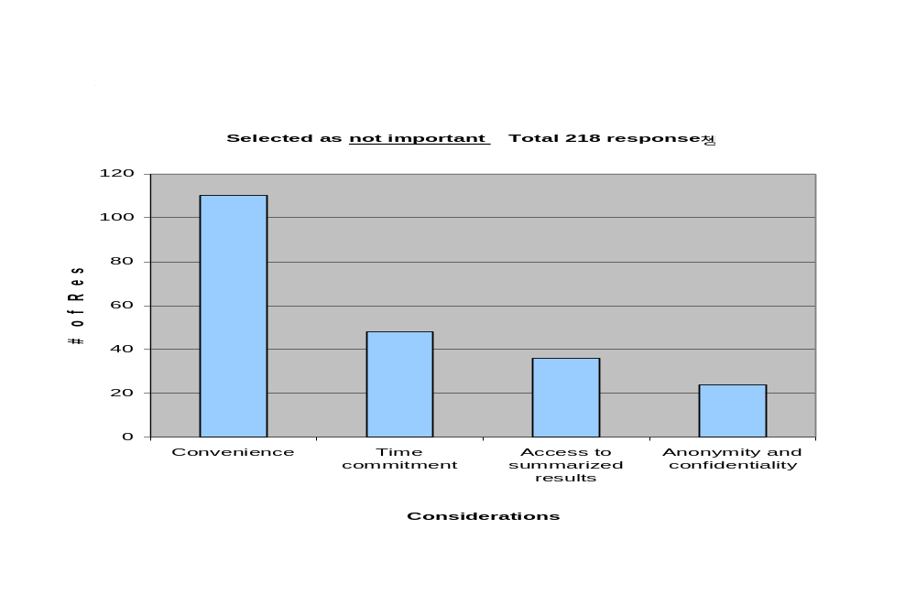

Selected as Crucial Total 755 Responses

0
50
100
150
200
250
300
350
Convenience
Time Commitment
Access to Summarized Results
Anonymity and Confidentiality
Considerations
# of Responses
Please mark the importance to you of each of the following for completing course evaluations: Convenience, Time Commitment, Access to Summarized Results, Anonymity and Confidentiality.
Not important -> Somewhat Important -> Important -> Very Important -> Crucial
78
113
236
328

Have you ever participated in an online course evaluation at Berkeley or any other higher educational institution?
0
100
200
300
400
500
600
700
Yes
No
# of Responses

614

153

767 Responses

0
10
20
30
40
50
60
Easy, Time Saving
Getting Instructor's Attention
Having a Say, Anonymity
Causes for positive experiences
# of Responses
85 Responses
57

7
25
Additional comments on positive online evaluation experiences.
Have you ever participated in an online course evaluation at Berkeley or any other higher educational institution?

0
5
10
15
20
25
30
35
Takes Too Long, Too Much Interface
Repetition of Standardized Questions, Results not Accessible
Causes for the negative experiences

# of Responses
Have you ever participated in an online course evaluation at Berkeley or any other higher educational institution?
Additional comments on negative online evaluation experiences.

52 Responses

30

22

Pen/Paper Evaluation 769 Responses
0
100
200
300
400
500
600
5-10 Minutes
11-15 Minutes
Over 15 Minutes
No Experience
Time Spent
# of Responses

525

212

27

5
On average, how much time do you spend completing a Pen/Paper course evaluation?

Online Evaluation 766 responses
0
100
200
300
400
500
600
5-10 Minutes
11-15 Minutes
Over 15 Minutes
No Experience
Time Spent
# of Responses
On average, how much time do you spend completing an online course evaluation?

187

72

29

478

766 Responses
0
100
200
300
400
500
600
700
Yes
No
# of Responses
Do you feel you have adequate time to complete in-class evaluations?

573

193

Selected as Unattractive 59 Responses
0
5
10
15
20
25
30
Earlier Access to Grade
UCB Student Discount
Access to Evaluation Summary
Benefits of completing course evaluations online
# of Responses

Please indicate the attractiveness of each of the following benefits of completing course evaluations online: Earlier Access to Grades, UCB Student Discounts, Access to Evaluation Summaries.
Unattractive -> Somewhat Attractive -> Attractive -> Very Attractive -> Crucial
26

19

14

Selected as Attractive (and beyond) 2,019 Responses
630
640
650
660
670
680
690
700
Earlier Access to Grades
UCB Student Discount
Access to Evaluation Summary
Benefits of completing course evaluations on-line
# of Responses

651

679

689
Please indicate the attractiveness of each of the following benefits of completing course evaluations online: Earlier Access to Grades, UCB Student Discounts, Access to Evaluation Summaries.
Unattractive -> Somewhat Attractive -> Attractive -> Very attractive -> Crucial

Selected as Crucial 517 Responses
0
50
100
150
200
250
Earlier Access to Grades
UCB Student Discount
Access to Evaluation Summary
Given benefits of completing course evaluations online
# of Responses
Please indicate the attractiveness of each of the following benefits of completing course evaluations online: Earlier Access to Grades, UCB Student Discounts, Access to Evaluation Summaries.
Unattractive -> Somewhat Attractive -> Attractive -> Very attractive -> Crucial

129
158

230

471 Responses
0
20
40
60
80
100
120
140
160
180
Extra Credit
Prizes, Tickets, Food
Knowing That I Made a Difference
Making It Mandatory
Easy to Use, Convenient and Confidential
No Other Incentive Necessary
Suggested incentives from students
# of Responses

What other incentives not yet mentioned would motivate student participation?

45

170

93
15

56
92

Total 746 Responses
0
100
200
300
400
500
Yes
No
# of Responses
Do you think the evaluations you have completed have had an impact?

393
353

416 Responses

0
20
40
60
80
100
120
140
160
180
200
Don’t Know, I Hope So
Yes, I Saw Changes
I Think So, I Was Told
Very little, Maybe for the GSI, or in a Small Class
No
Comments
# of Responses

Do you think the evaluations you have completed have had an impact?
172
84
61
34
65

0
100
200
300
400
500
600
700
Yes
No
# of Responses

Would you be willing to fill out an online course evaluation outside of class time?

770 Responses

611
159

Appendix H: Faculty Interviewees and Interview Questions

Faculty Interviewee List

Agogino, Alice: Professor of Mechanical Engineering and Vice Chair Academic Senate
Auslander, David: Professor of Mechanical Engineering and Associate Dean for Research and Student Affairs, College of Engineering
Broughton, Janet: Professor of Philosophy and Chair, and Chair, Budget & Interdepartmental Relations Committee, Academic Senate
Brown, Clair: Professor of Economics and Member of Educational Policy Committee, Academic Senate
Chhibber, Pradeep: Professor of Political Science and Department Chair
Collignon, Fred: Professor of City and Regional Planning, and Undergraduate Dean, College of Environmental Design
Duncan, Ian: Professor of English and Department Chair
Gilbert, Richard: Professor of Economics and Department Chair
Hexter, Ralph: Professor of Classics and Comparative Literature, and Executive Dean and Dean of Arts & Humanities, College of Letters and Science
Hinshaw, Stephen: Professor of Psychology and Department Chair
Hinton, Leanne: Professor of Linguistics and Department Chair
Hollinger, David: Professor of History and Department Chair
Holub, Robert: Professor of German and Dean of Undergraduate Division, College of Letters & Science
Johns, Michael: Professor of Geography and Department Chair
Knapp, Robert: Professor of Classics and Chair of the Academic Senate
Malik, Jitendra: Professor and Chair of Electrical Engineering and Computer Science
Martin, W. Mike: Professor of Architecture and Department Chair
Mascuch, Michael: Professor of Rhetoric and Associate Dean, Arts & Humanities, College of Letters & Science
Omi, Michael: Professor of Ethnic Studies and Department Chair
Owen, W. Geoffrey: Professor of Neurobiology and Dean of Biological Sciences, College of Letters and Science
Richards, Mark: Professor of Earth and Planetary Science, and Dean of the Physical Sciences, College of Letters & Science
Shogan, Andrew: Professor and Associate Dean for Instruction, Haas School of Business
Small, Stephen: Professor of African American Studies and Department Chair
Spanos, Costas: Professor of Electrical Engineering and Director, Electronics Research Laboratory
Stark, Philip: Professor of Statistics, Member of Committee on Education Policy, Chair of Educational Technology Committee
Szeri, Andrew: Professor of Mechanical Engineering and Chair, Graduate Council Committee, Academic Senate
Thorne, Barrie: Professor of Women’s Studies and Department Chair
Tongue, Benson: Professor of Sociology and Department Chair
Voss, Kim: Professor of Sociology and Department Chair
Wachter, Ken: Professor of Demography and Department Chair

Faculty Interview Questions

- How are evaluations currently being managed in your courses/department?
- How much in-class time do you currently allocate for course evaluations?
- Do you use both formative and summative evaluations?
- Starting from the time that students take evaluations, how long do you wait until you see the results? Can you, or would you prefer to see the results sooner?
- How much time/resources does your department spend on the course evaluation process? Can you quantify the cost of this for us?
- Would your department be willing to pay a fee in order to offload much of the evaluation administration to central campus?
- In what format do you get the evaluation results (e.g. raw data, photocopies of all evaluations, a summary report from the department, etc.)
- How do you use the results?
- How useful are the evaluation results to you?
- Has error in transcription of the paper-based forms ever been an issue within your department?
- How much flexibility/customization (in the questions used for evaluation) do you currently have?
- Would you prefer more or less customization?
- One of the concerns we have learned about in our research is how response rates for online versus paper evaluations compare. Do you have any statistics on the response rate for your classes/department's method of evaluation?
- How might we motivate students to participate in online evaluations?
- What do you perceive as the deficiencies in a paper driven evaluation methodology?
- Overall, is the current evaluation system satisfactory? What do you like/dislike about it?
- What do you see as the benefits of using the online approach?
- What are your concerns about moving to an online evaluation system?
- What features do you need in an online course evaluation?
- Is there anything that exists in the paper version that you do not want to lose in an online format?
- Besides the one question agreed to by the entire campus, do you need to be able to include your own questions, or is the template used by your department sufficient?
- What in your mind is the single most important feature for a new system?
- Do you need to be able to see historical data?
- Would reports that combine evaluation data over multiple years be helpful to you?
- There are variations across campus as to the level of access to evaluation results -- some departments make results available to students and the general public, while others limit access to faculty and chairs only. What level of access are you comfortable with?
- Do you think students should have access to the results?
- Is there anything else you'd like to mention about your needs/concerns/expectations for an online evaluation system?

Appendix I: Staff Interviewees and Interview Questions

Staff Interviewee List

Castillo-Robson, Susie: University Registrar, Office of the Registrar
Donnelly, Patricia: Director, IS, Boalt School of Law
Francisco, Adrianne: Instructional Analyst, Haas School of Business
Hadley, Malla: Management Services Officer, City and Regional Planning
Hancock, Mara: Associate Director-Learning Systems, Educational Technology Services
Hengstler, Dennis: Executive Director, Office of Planning and Analysis
Miles, Karen: Educational Technology Services
Owen, Patty: Director, Academic Personnel
Owen, Steve: Management Services Officer, Integrative Biology
Prater, Vida: Assistant to the Dean, International and Area Studies
Stark, Phillip: Professor, Statistics

Staff Interview Questions

- Are you currently involved in the pen and paper evaluation system? If yes, what is your role?
- How do you currently manage your paper-driven evaluation data? Are the evaluations stored centrally in your unit or with the faculty person?
- What process is used in your department when evaluation data is needed for faculty personnel actions?
- Does your department make your evaluation results public? If so, how and to whom? If not, why not?
- What are your data retention guidelines (e.g., how long does your department keep evaluation forms? Compiled results?)
- How much time/resources does your department spend on the course evaluation process? Can you quantify the cost of this for us? Staff time? Distribution (postage for mailing results to faculty)? Photocopying?
- Does your involvement in the current pen and paper evaluation add significantly to your workload? If yes, how many hours per semester do you feel that it adds to your current workload?
- Do you have any statistics on the response rate from the paper evaluations your department currently uses?
- Have you ever participated in an online course evaluation program? If yes, would you consider that your role changed significantly because of the participation? If yes, please describe what changed (workload, responsibilities, etc.).
- What do you see as the benefits of using the online approach?
- What are your concerns about moving to an online evaluation system?
- How do you believe your work-load would be affected by the implementation of a permanent online course evaluation?
- Do you see your involvement in an online course evaluation as having a positive impact on the overall process of course evaluations? If yes, in what manner? If no, why? If no, how do you see the change to an online system affecting you, if at all?
- What is your biggest concern about the transition from paper to an online process?
- What features do you see as necessary in an online course evaluation system?
- How might we motivate students to participate in online evaluations?
- Is there anything else you'd like to mention about your needs/concerns/expectations for an online evaluation system?

Appendix J: Student Information Systems Mid Semester Evaluation Questions

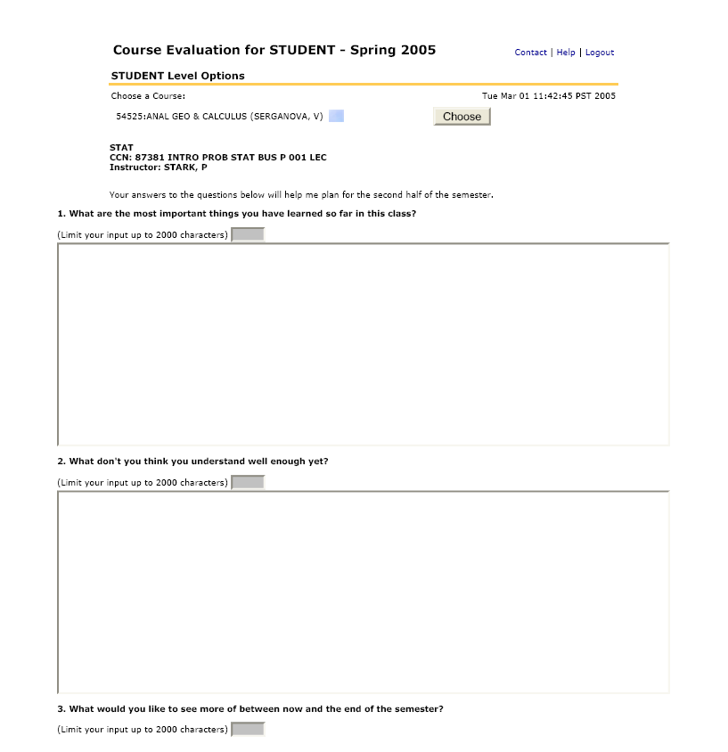
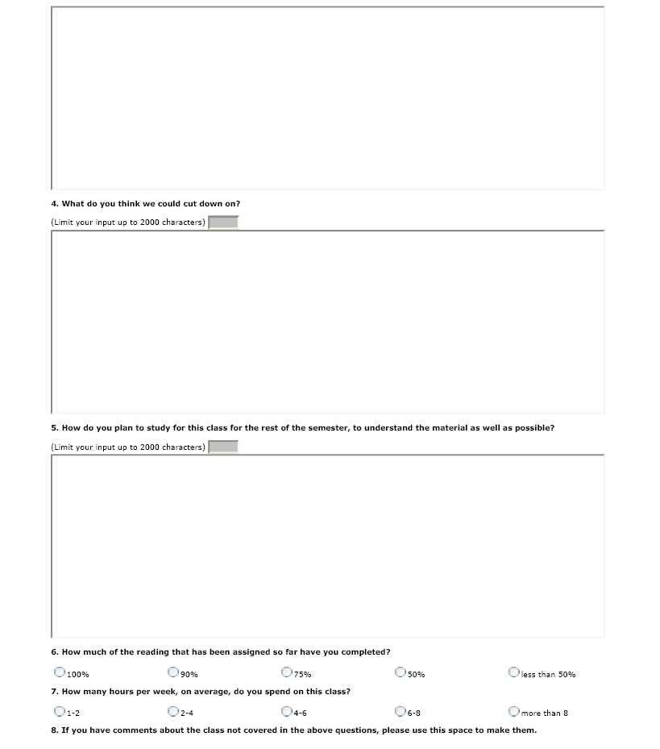
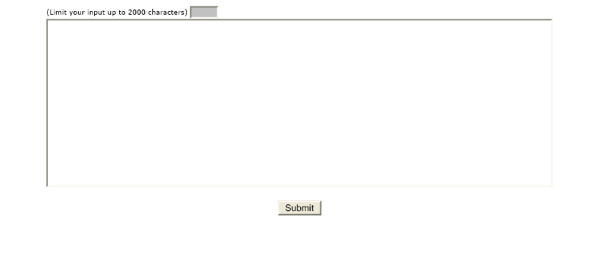

Appendix K: Student Information Systems Prototype Application Screen Capture

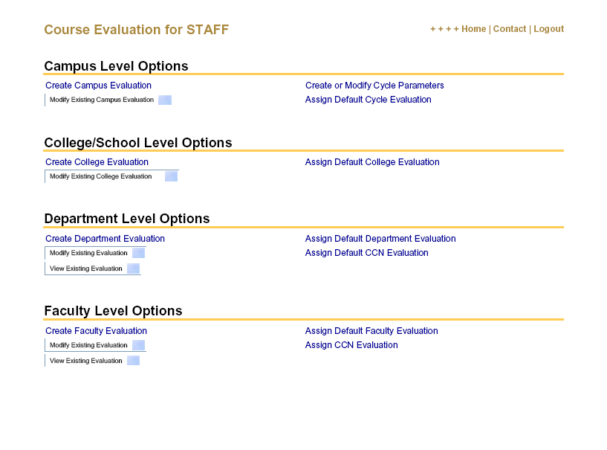

Appendix L: UC Berkeley Homepage Student Survey Announcement
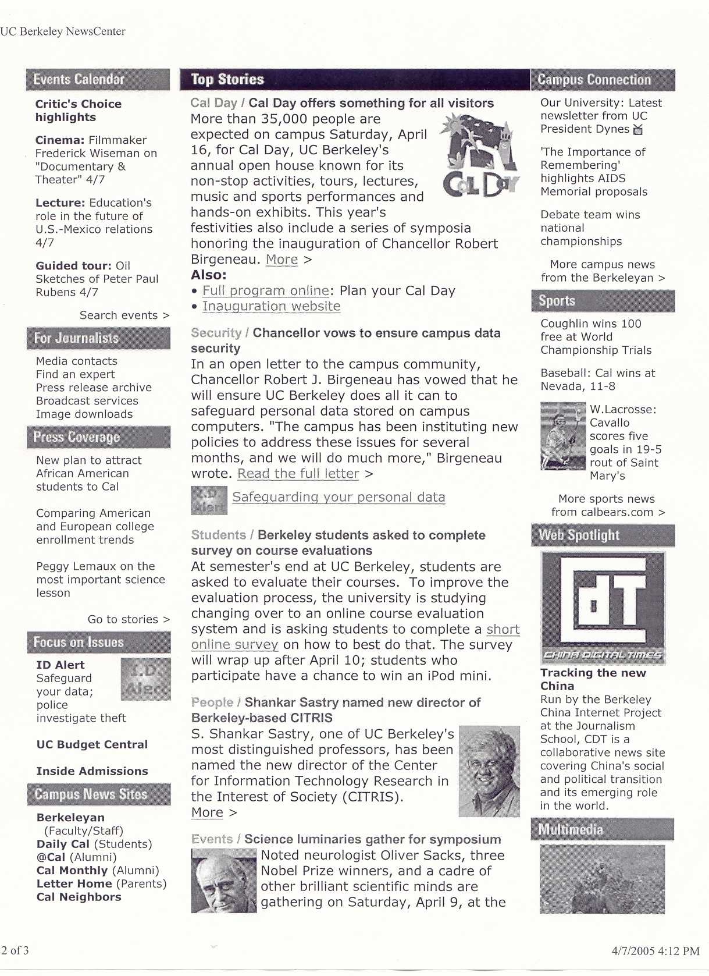

Appendix M: UC Berkeley Web Feature on Student Survey iPod Winner

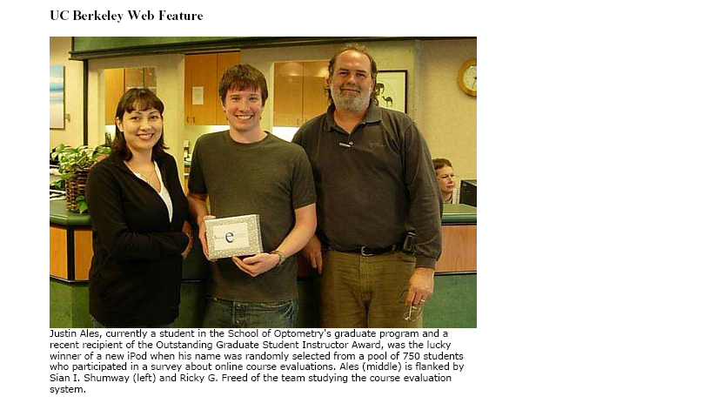
Campus study of online course evaluations heads into the home stretch
9 May 2005
BERKELEY – A recent survey on the possible development of a system to allow courses to be evaluated online by students drew responses from more than 750 students. The survey, conducted by a campus Leadership Development Program (LDP) group, provides important data, says Michael Hardie of Educational Technology Services and co-sponsor of the project.
"Team members have been interviewing campus staff and faculty, and now, with input from students, they will have surveyed representatives of all the participants in the course evaluation process," said Hardie.
The LDP project, originally proposed by Vice Provost of Undergraduate Education Christina Maslach and Assistant Vice Provost Barbara Davis, and vetted by the Chancellor's cabinet, is designed to assess the best practices in online evaluation systems at other educational institutions and to determine what would work best at UC Berkeley.
The LDP team has interviewed key Berkeley campus stakeholders as well as representatives from comparable educational institutions that have online course evaluation systems, and will report its findings on May 24. Members of the LDP team include Eric P. Anglim, Karen Berk, Ellen S. I. Chang, Ricky G. Freed, Liz Marsh, Sian I. Shumway, and Trang Tran.
With the campus examining how to streamline its academic personnel review process, of which the current paper-based course evaluation system is a part, the LDP team's report will have a receptive audience. Anticipating that the course evaluation process could move to an online venue in the not-too-distant future, Davis along with staff from Student Information Systems, the Office of Educational Development, and the Registrar's office have developed a prototype of an online system and hope to begin major testing of that prototype beginning next fall. A very small scale pilot using the prototype will be tested at the end of the current spring semester.

Appendix N: Website Resource Summaries

Resource | URL | Category | Summary
UC Berkeley Policy for the Evaluation of Teaching | http://apo.chance.berkeley.edu/evaluation.html | Campus Policy | 1987 memo from Provost C. Judson King to all Deans, Schools, and Colleges, forwarding Senate Committee on Teaching's policy guidelines for the evaluation of teaching for the purposes of faculty promotion or advancement. Discusses the criteria for advancement promotion (teaching and research excellence), aspects of teaching to be evaluated, sources and methods for evaluating teaching (student course evaluations are just one), and elements of the Teaching Dossier.  Also includes Recommendations for Administering and Analyzing Student Course Evaluations (i.e. frequency of administration, procedures for administering student evaluation forms, and procedures for analyzing student evaluation forms).
Campus Administrative Memo Articulating the Single Question Policy | http://www.berkeley.edu:5027/cgi-bin/deans_memos/deans_memos.pl?display_memo=1332  http://www.berkeley.edu:5027/cgi-bin/deans_memos/deans_memos.pl?display_memo=1402 | Campus Policy | A one-page memo (dated 4/2/02) to Campus Deans & Department Chairs from the Vice Provost for Academic Affairs (Jan de Vries) on their views regarding the following standard question (first recommended in 1975, reviewed and reiterated in 1987) and the seven-point scale on all teaching evaluation forms:  Considering both the limitations and possibilities of the subject matter and course, how would you rate the overall teaching effectiveness of this instructor?
UC Teaching, Learning, & Technology Center (TLtC) article on course evaluations | http://www.uctltc.org/news/2004/04/feature.html | Best Practices | This article, written in April by the Associate Director from the UC Teaching, Learning and Technology Center, Paula Murphy, refers to the process of "pixels instead of paper which is still relatively slow to be adopted". Even by the study in early 2003 that "found that 90% of the nation's "most wired" colleges still used a paper-based process. However, the 10% using online systems represented an 8% increase from 2000, thus there appears to be a gradual movement toward the online process."  Incentives are also outlined as "necessary" in order to promote high response rates; including providing extra credit or entering students in raffles for prizes. Of primary import was communicating with students early and often about the evaluation process and how the data will be used; and withholding grades unless students submit their online evaluations being cited in one pilot at UCLA Medical.  Replete in the article are encouraging references to inclusion and student input. Also significant is the common practice of ensuring anonymity with the online systems is to utilize two databases that separate the login information from the actual feedback.
Using the web for student evaluation of teaching | http://home.ust.hk/~eteval/cosset/qtlconf.pdf | Best Practices | This site details the efforts to develop, implement and evaluate web-based systems for online teaching evaluations at Hong Kong University of Science and Technology and Hong Kong Polytechnic University. They developed and implemented two web based systems. This paper details the design,  administration and provides some data on student and professor views on online evaluations.
Online Student Evaluation of Instruction: An Investigation of Non-Response Bias | http://airweb.org/forum02/550.pdf | Best Practices | The research described in this paper was intended to examine whether significant differences exist in student responses to a course evaluation instrument based on the delivery method, in-class paper vs. web-based. There were 2 issues of greatest concern: 1) low response rate 2) non-response bias (e.g., correlation of lower response rates with specific  demographic factors)  The results of the study suggest that concerns regarding low response rates and the potential for non-response bias may not be warranted, although the author recommends that campuses replicate this study on their own campuses to verify the findings.
Online Student Evaluation of Teaching in Higher Education | http://onset.byu.edu/ | Best Practices | The site is being developed as an informational portal for those contemplating the implementation of an Online Student Evaluation of Teaching in Higher Education system as well as for those who have such a system already in place. In an effort to compile pertinent information on the topic, an extensive web search and communication with over 100 institutions of higher education was conducted. In addition, a literature review of recent relevant articles and publications was performed. The results are posted under these categories: OnSET Institutions and Resources, which include an annotated bibliography of printed articles and a list of commercial resources.
Online Student Evaluation of Teaching in Higher Education: An Annotated Bibliography | http://onset.byu.edu/OnSETbiblio.htm | Best Practices | See Above
Web-based Student Evaluation of Instruction: Promises and Pitfalls | http://www.drexel.edu/provost/ir/conf/webeval.pdf | Best Practices | An experiential summary of Columbia and Drexel Universities implementation of web-based student course evaluations. The document discusses their motivation to convert from a paper based system to a web-based system, strategies employed by both universities to ensure maximum student participation, student and faculty benefits born from a web-based evaluation system, and the challenges in achieving student participation. Additional discussion touched upon how a standardized set of survey questions could be expanded upon by faculty to achieve meaningful feedback specific to discrete classes and allow faculty and administration to track improvement or regression in course goals.
Plugging in to course Evaluation | http://ts.mivu.org/default.asp?show=article&id=795 | Best Practices | September 2000 article from The Technology Source, published by the Michigan Virtual University. Discusses the challenges and benefits of transferring to online course evaluations, as identified by a recent survey of the nation's "200 most wired colleges" by Rensselaer Polytechnic Institute's Interactive and Distance Education Assessment (IDEA) Laboratory. Includes interesting info re: cost of conversion, return rates and response quality for online vs. paper evaluations.  Also advocates for going beyond the concept of just putting the evaluation on the web. A "fully developed" web-based evaluation system would incorporate a "feedback-and-refinement process" of frequent exchange of information between students and instructors throughout the semester to guide course refinement. "Shifts the definition of quality instruction from getting high scores to using student feedback to facilitate change."
Yale University Online Course Evaluation FAQ | http://classes.yale.edu/help/itg/oce/faq.htm | Best Practices | ...a 'Frequently Asked Questions' page for the Yale University Faculty of Arts and Sciences Online Course Evaluation...I gleaned many helpful insights into the "Yale" way of doing things which of course led me deeper into their web environment and into some very interesting directions which we may indeed incorporate into our final recommendations regarding what *not* to do...I've adapted the page itself (with a little re-write) and would submit it as such (with credit given) for all the group to peruse.
Northwestern University Course & Teacher Evaluation Council | http://www.registrar.northwestern.edu/ | Best Practices | The site to Northwestern University’s –The Course and Teacher Evaluation Council (CTEC) with policies, guidelines to the faculty, teaching assistant and students open to public access; Instructor access to CTEC results, TA reports, and sample form and guide, on the other hand, are user words/password protected.

Hoffman, K. (2003). Online course evaluation and reporting in higher education," New Directions for Teaching and Learning, 2003(96), 26.
bSpace is UC Berkeley’s implementation of the SAKAI collaboration suite, and will replace existing Learning Management systems on the Berkeley campus.
Use cases describe how end-users will use a software code. It defines a task or a series of tasks that users will accomplish using the software, and includes the responses of the software to user actions.
Load testing generally refers to the practice of modeling the expected usage of a software program by simulating multiple users accessing the program's services concurrently.
“Considering both the limitations and possibilities of the subject matter and course, how would you rate the overall teaching effectiveness of this instructor?” (Rated on a 7-point scale, from Not at all effective to Extremely effective.)

